
Account Creation Process

7/31/2026
Version 1.3

Contents
Login Screen 3
Choose a Domain 4
Confirm Selection 6
Account Information 7
Check Out 8
Thank You 9
Members Area – Account Support Login 10
Members Area – Online Control Panel 11

Login Screen
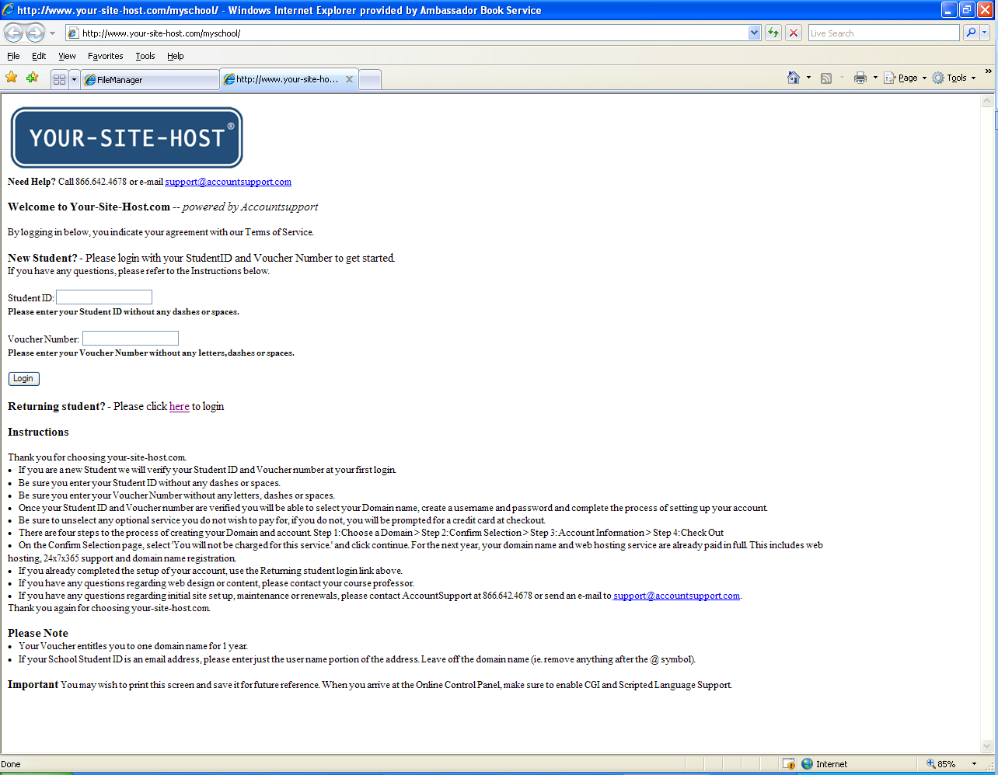
This is the first screen you will see when you browse to http://www.your-site-host.com/myschool/index.htm. If you are a New Student who has not yet setup an account, use the New Student section to Login using your Student ID (the ID number you gave at the bookstore to obtain your course materials) and Voucher number (the number in boldface on the upper left of the receipt provided by the bookstore, Note: use only the number part of the Voucher Number, not the School prefix). Your Student ID and Voucher number will be verified at your first login. (Note: During the Account setup process, you will create a Username and Password. Subsequent logins to your account will use Username and Password).
Once your Student ID and Voucher number are verified you will be able to select your Domain name, create a username and password and complete the process of setting up your account. There are four steps to the process of creating your Domain and account. Step 1: Choose a Domain > Step 2: Confirm Selection > Step 3: Account Information > Step 4: Check Out
(Note: On the Confirm Selection page, select 'You will not be charged for this service.' then click continue. For the next year, your domain name and web hosting service are already paid in full. This includes web hosting, 24x7x365 support and domain name registration.)

Choose a Domain
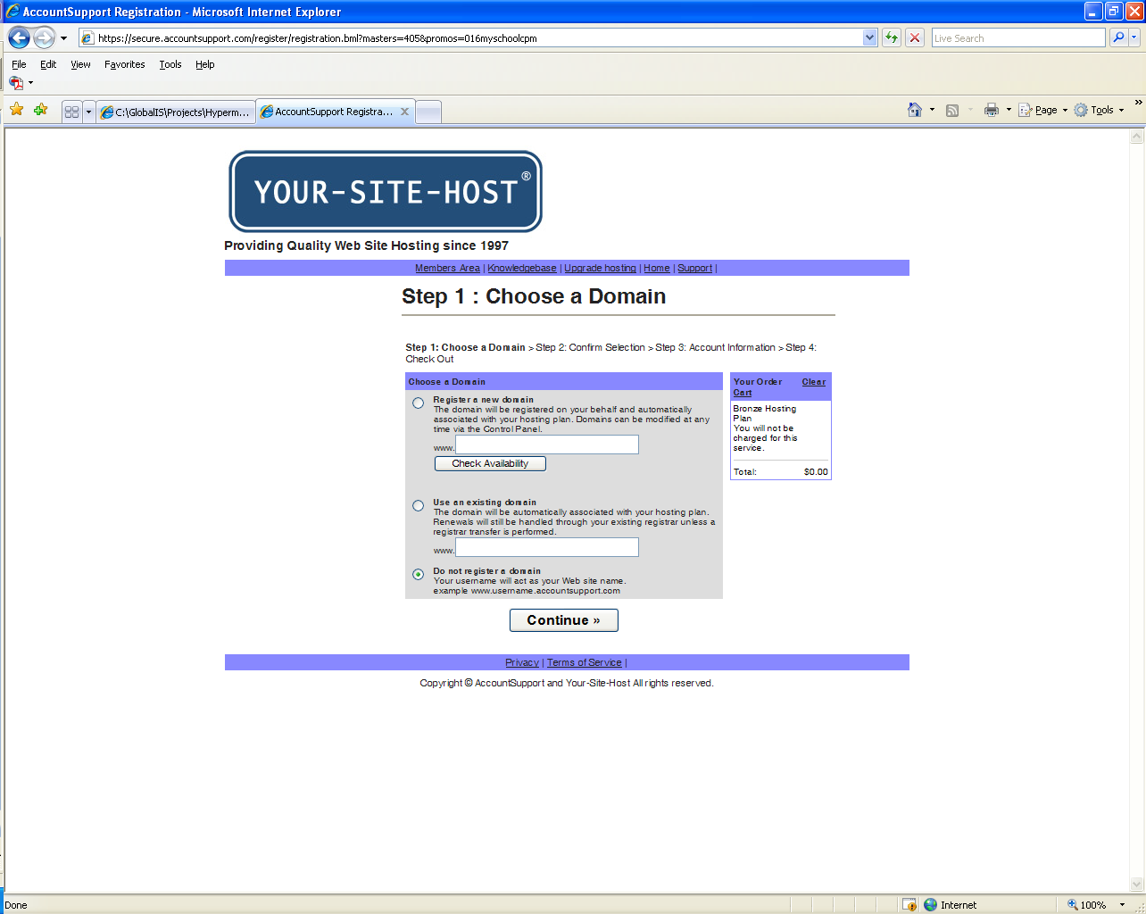
Using the Choose a Domain screen you can:
- Register a new Domain – Enter the desired Domain name in the box after the www. If the Domain name is available, the domain will be registered on your behalf and automatically associated with your hosting plan. Domains can be modified at any time via the Control Panel. Use the Check Availability button to see if the Domain name you want is available. If the Domain name is not available you will be presented with the screen which follows.
- Use an existing Domain – If you already own an existing Domain name, use this option to associate that Domain name with your account. The domain will be automatically associated with your hosting plan. Renewals will still be handled through your existing registrar unless a registrar transfer is performed.
- Do not register a Domain – Choose this option if you do not want to create a domain name at this time. It can be done later. Your username will act as your Web site name. (ex: www.yourusername.accountsupport.com)
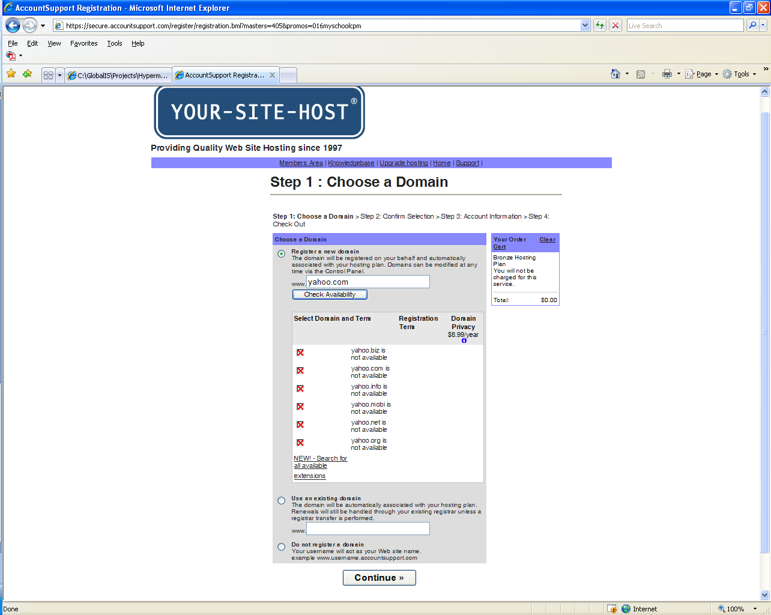

If the Domain name you selected is not available you will see a screen similar to the screen above. You can adjust the Domain name and try again by clicking the Check Availability button.
(Note: Unselect any optional billable items on this screen or at checkout time you will be asked for a credit card.)

If you have chosen an available Domain name, or chosen to use an existing Domain name, or selected not to register a Domain at this time, click the continue button to move to the second step of the process.
Confirm Selection
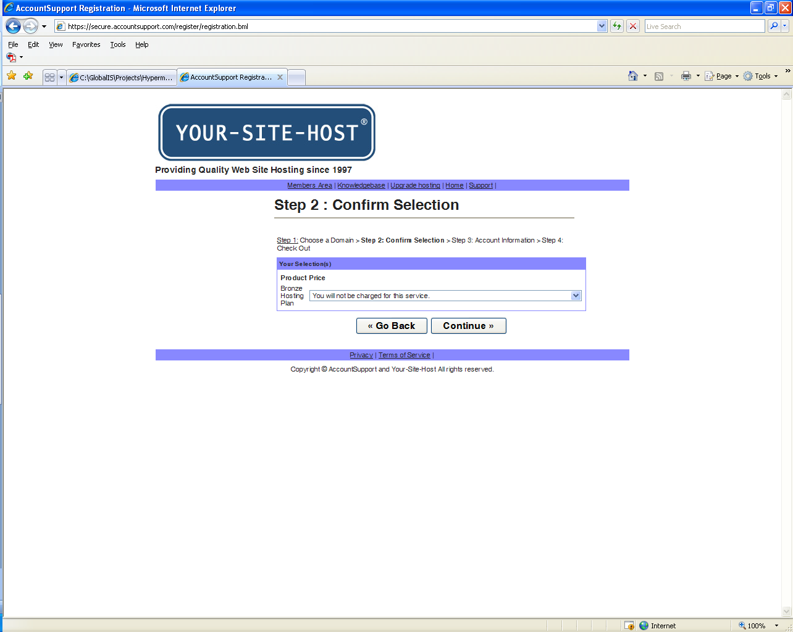

On the Confirm Selection page select 'You will not be charged for this service.' then click continue. For the next year, your domain name and web hosting service are already paid in full. You will be brought to the third step in the process, Account Information.

Account Information
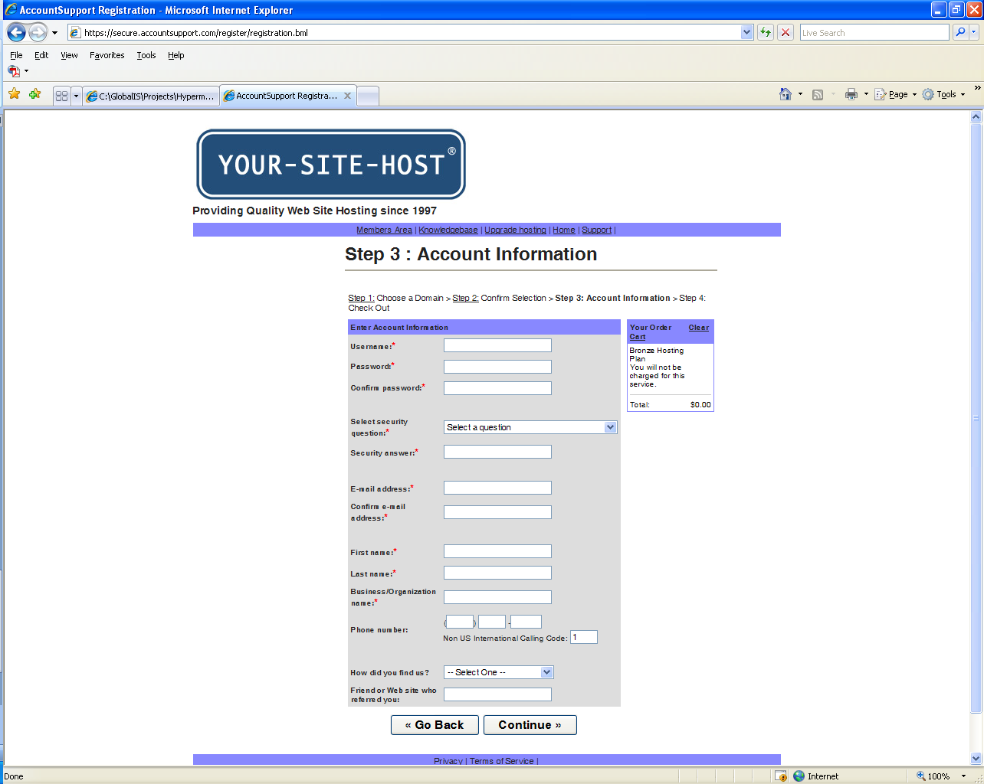
Use this page to enter your account information and create your user name and password. Once you successfully create your user name and password using this screen, you will no longer login with your Student ID and Voucher number. (Note: The password you create must contain at least one letter and one number or punctuation character.)

Complete all required items on the page and click continue. You will be brought to the final step in the process.

Check Out
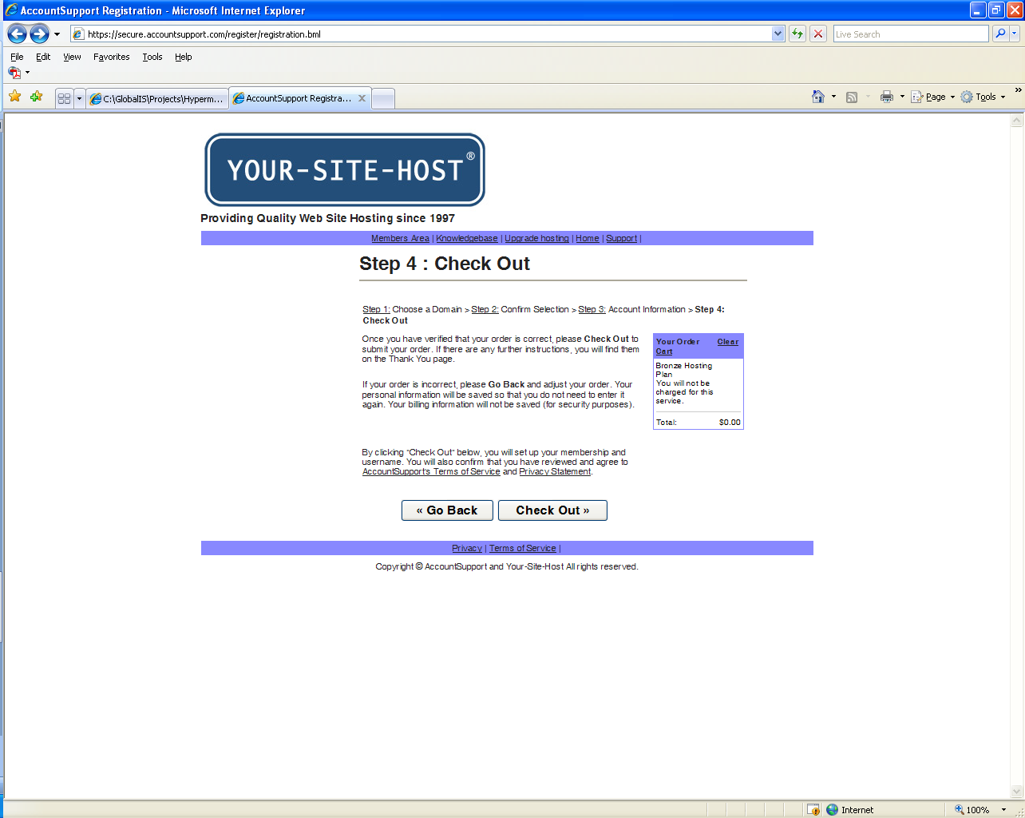

On the Checkout page you have an option to go back and make changes or check out and complete the process. (Note: If you did not unselect any optional billable items at Step One you will be asked for a credit card when you click the Check Out button. If this happens, you can deselect the billable item in the small shopping cart list to the right of the screen.)

Thank You
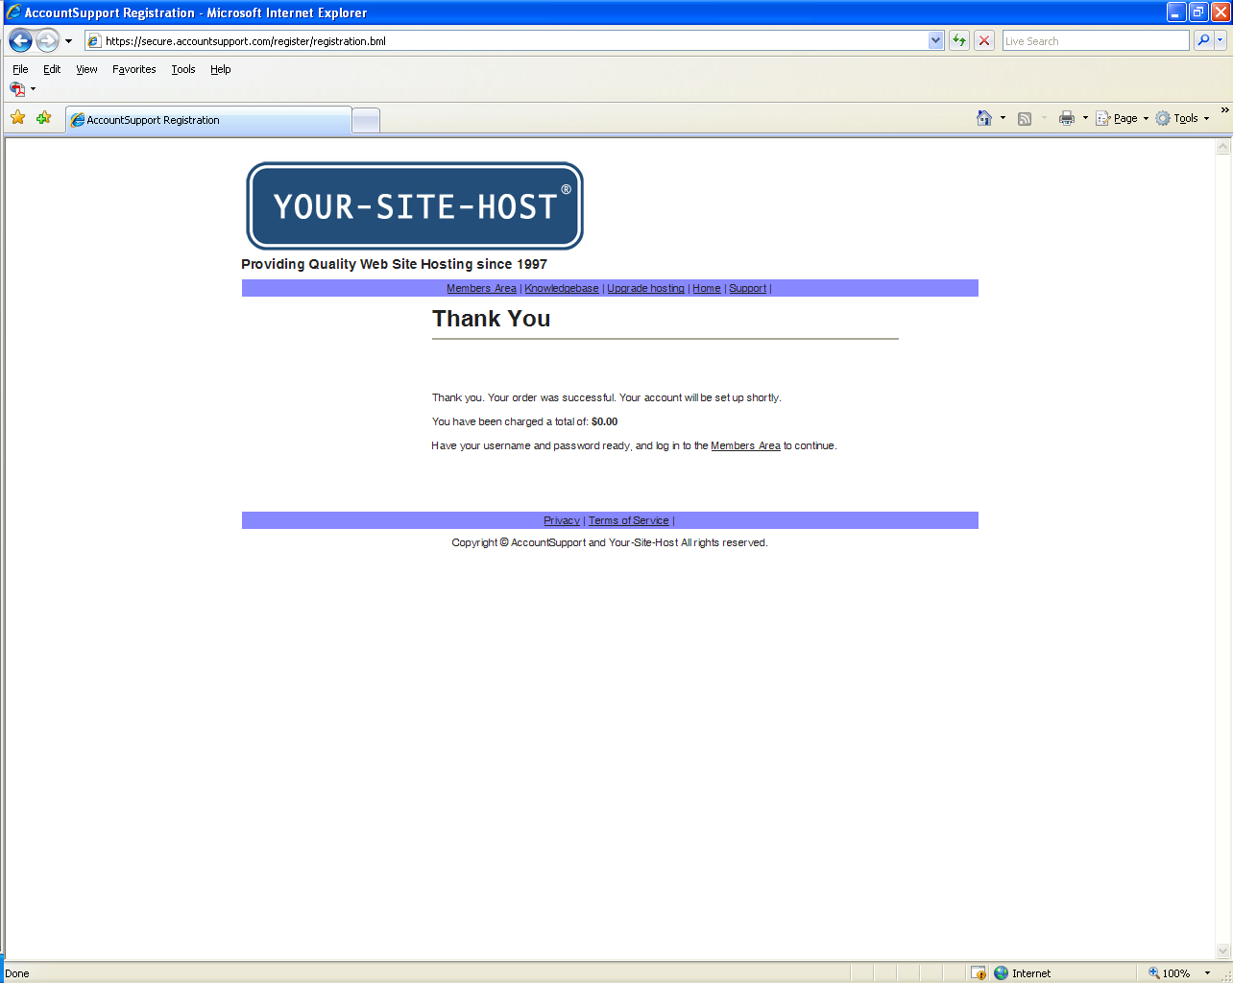
On successful checkout you will be presented with a Thank you page. Your login will be activated usually within one business day.

Members Area – Account Support Login
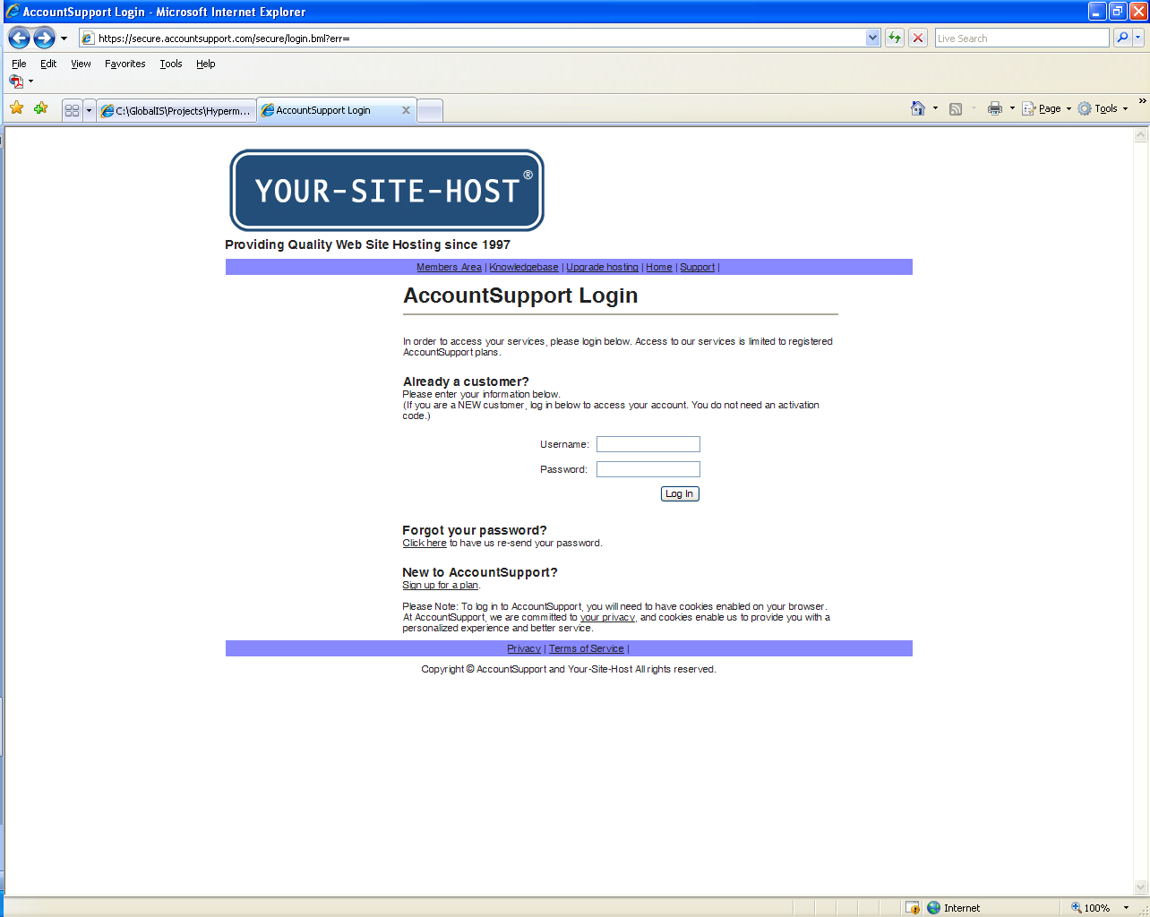
The Account Support Login screen is the access point into your account. To get to this screen use the following URL: http://www.your-site-host.com/

Enter the username and password you entered on the Account Information screen and click Log In. You will be presented with the Online Control Panel screen which gives you full access and control of your web site and Domain.
Members Area – Online Control Panel
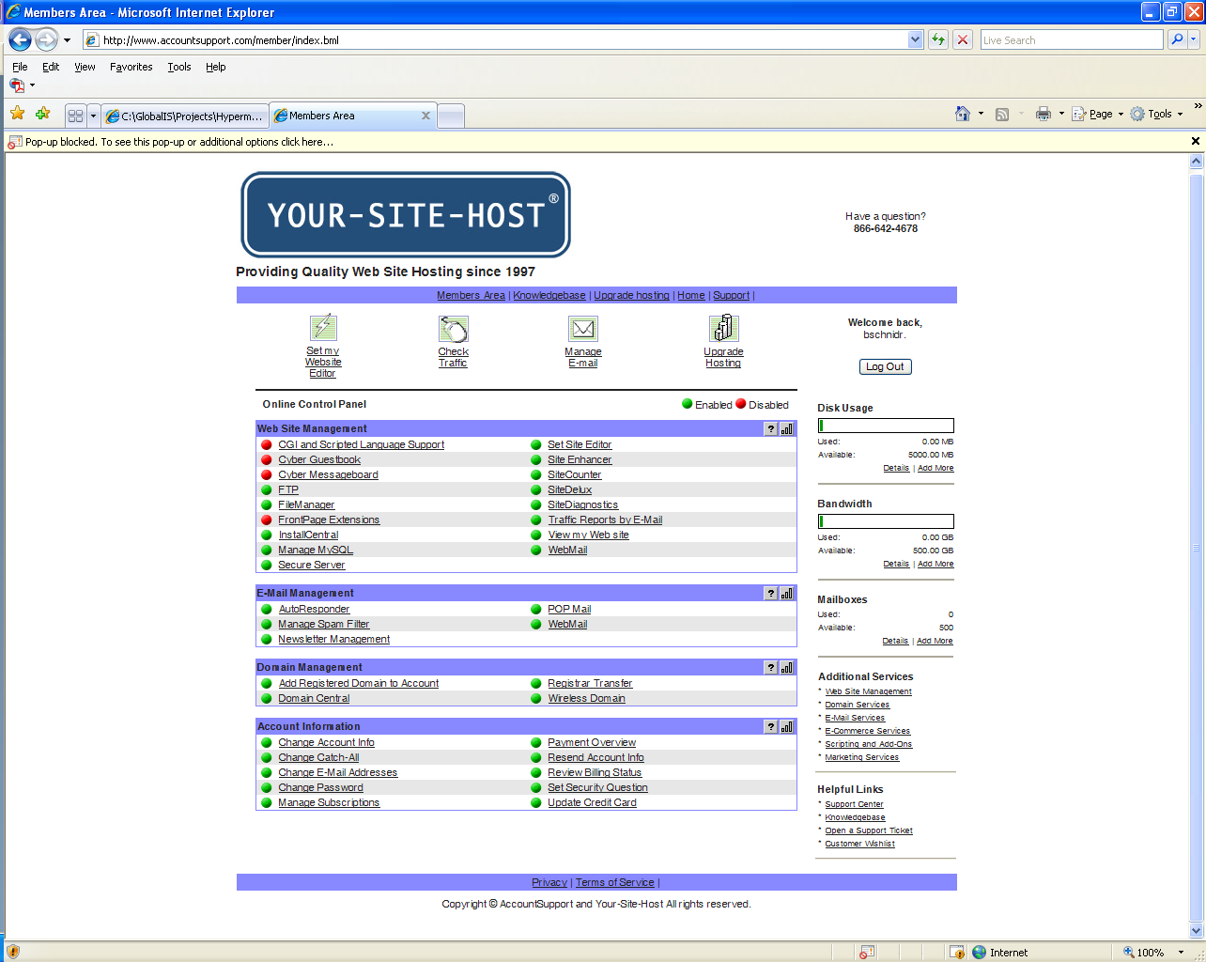
The Online Control Panel is the access point to all the features and setting for your site. If you have any questions about this screen, contact technical support at (866) 642-4678 or email support@accountsupport.com.

